How to check/confirm MSPN/Rev information has been entered correctly into Oracle.
- Open Oracle (Get the install here)
- To manually get there go to the top hat and click it
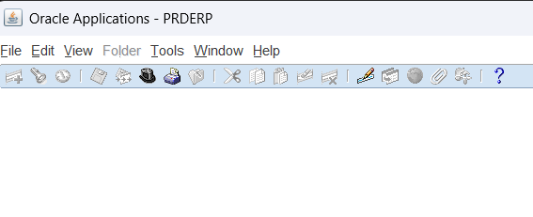
- Remove the % and search Bus Ops - WWT
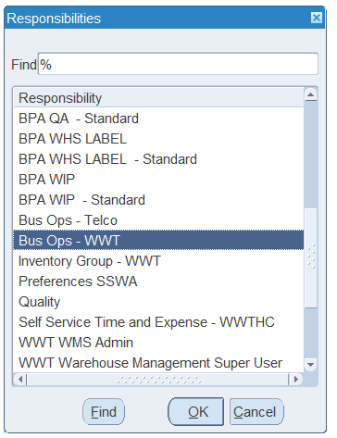

- Hit CTRL + L to open the Form Functions lookup. (If going to manually)
- Enter Master Items. (Choose the top “master items”. (If going to manually)

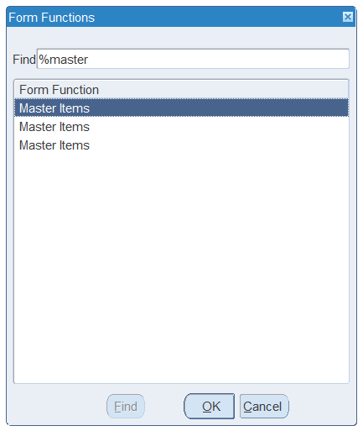
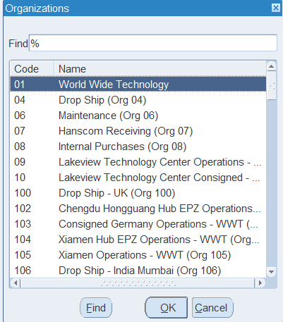
- In find type 40 after removing the %
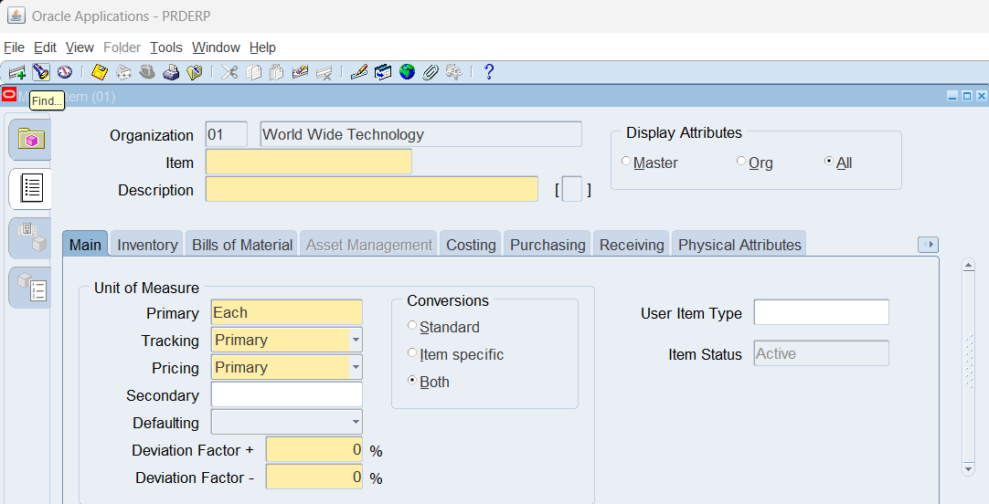
- In the Attribute Groups tab, click on the Find flashlight.

- Enter your finished good on MES ex: (MSF-102795.ACTUAL.854.MSN/CSCO)
- Click on the Zoom icon to see the entered MSPN/Rev information.
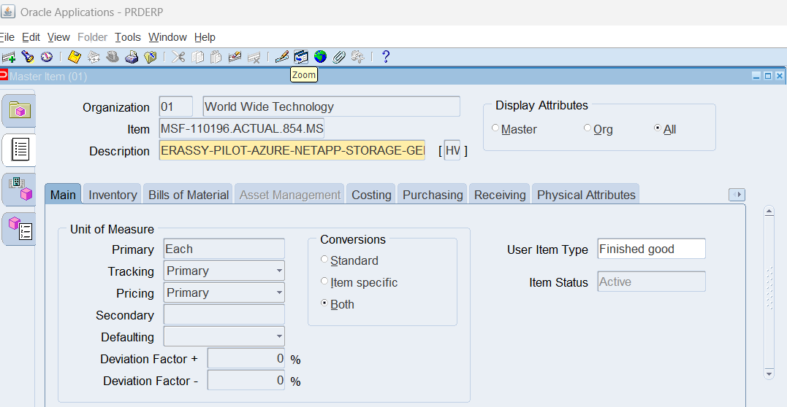
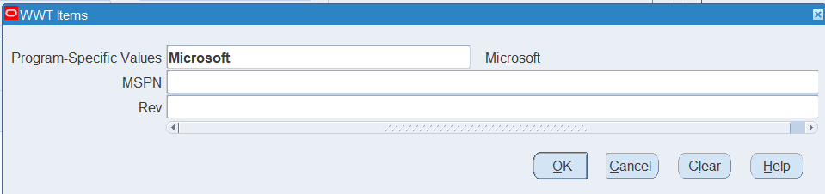
If program-specific values is empty, select Microsoft. If MSPN and Rev are empty then this information has not been input into Oracle.

